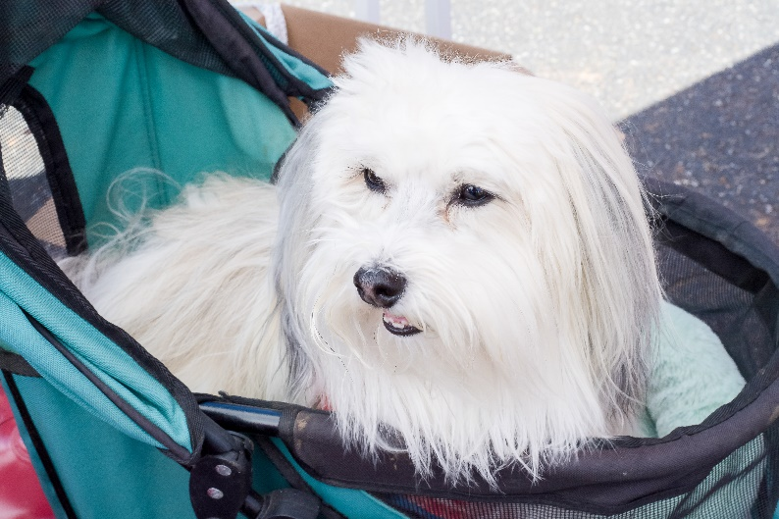

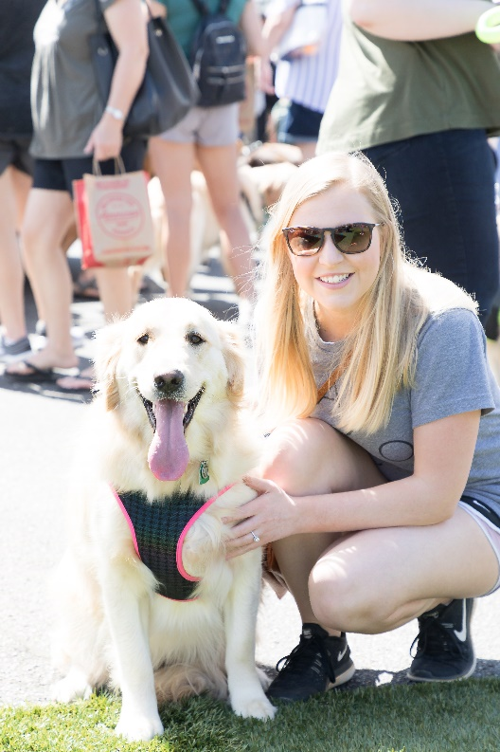
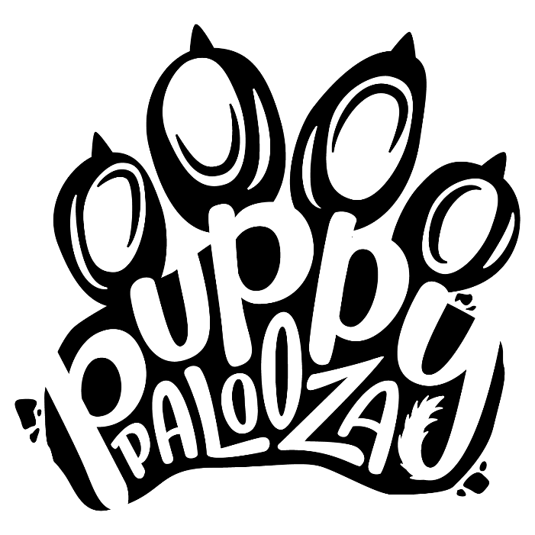

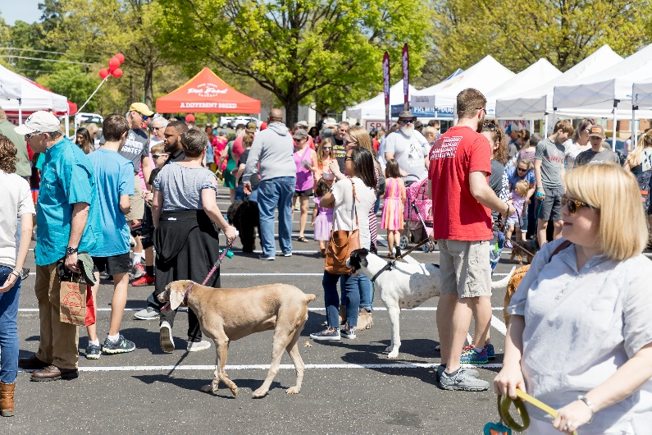
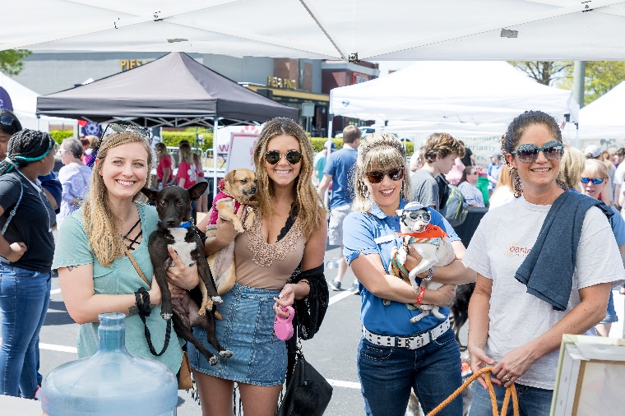

SATURDAY, APRIL 4, 2020 | 11 AM – 2 PM
{PAW}TNERSHIP OPPORTUNITIES
SATURDAY, APRIL 25, 2020 | 11AM – 2PM

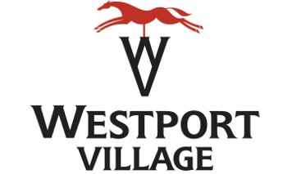

Thank you for considering a sponsorship opportunity for Westport Village’s first Puppy Palooza! This pawsitively fun event ensures the Ulti-Mutt day out for pups and their humans too! We hope, with your support, to make Puppy Palooza a huge success and look forward to helping Louisville’s neediest animals.
We are thrilled to announce that Puppy Palooza 2020 will benefit the Kentucky Humane Society! The Kentucky Humane Society is a nonprofit animal welfare organization that helps find homes for 6,000 animals per year, plus pet retention and education programs.
Puppy Palooza will include live music, a Fido marketplace, doggy activities, k9 splash zone, and much more! This community event is free and fun for the whole family.
Enclosed please find a description of the sponsorship opportunities along with the required application and event details. We hope that together, we can make Puppy Palooza a wonderful event to remember. Please do not hesitate to contact me with any questions.

Sincerely,
  - Carmen Schreiber
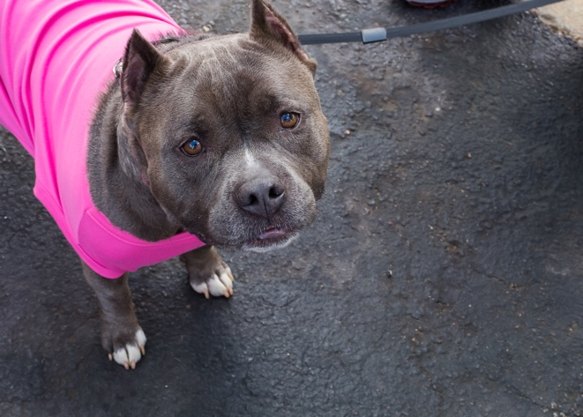
  - Marketing Associate, Westport Village
cschreiber@westportvillage.com
502.403.9683

{PAW}TNERSHIP OPPORTUNITIES
Doggy Splash Zone Sponsor | $500
This will be the most popular location at Puppy Palooza and will feature large and small dog pools for splashing and cooling off in two locations. This huge attraction gives you a wide and captive audience for your brand and message!
- 10x10 booth space at or near each doggy splash zone
- 6ft banner with name and logo at doggy splash zone
- Logo placement in Puppy Palooza email sent to 3,000+ recipients
- Minimum of 2 mentions on event social media pages
- Distribution rights at Doggy Splash Zone
- Logo and recognition on The Ulti-Mutt Puppy Palooza Guide distributed to all attendees
Exhibitor | $100
Join us in sharing your business with Louisville’s coolest dog owners.
- 10x10 booth space in the Fido Marketplace
- Distribution rights at booth
- Minimum 1 mention on event social media pages
In-Kind Sponsor
Westport Village Puppy Palooza is in need of the following to help us make a successful event. In return, your business will be listed as a sponsor on social media pages, as well as recognition at the event.
- Dog treats and bowls
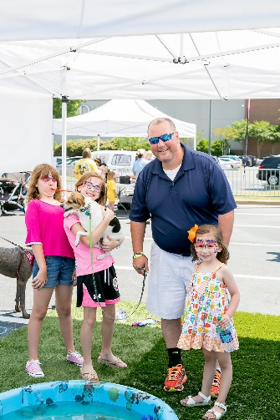
- Large and small pools
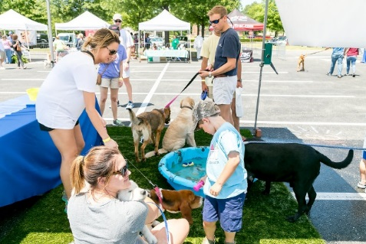
- Doggy Disposal Stations

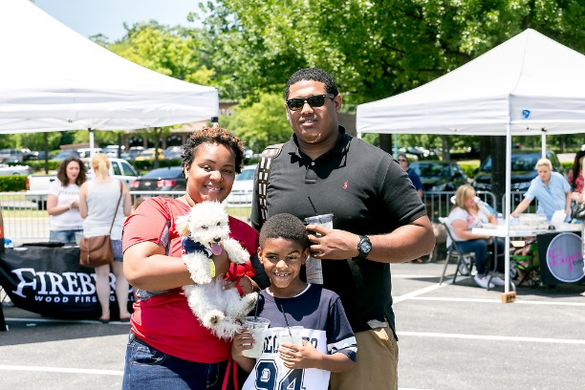

{PAW}TNERSHIP APPLICATION
Name of Business: ____________________________________________________
Contact Person: ____________________________________________________________________
Address: ___________________________________________________________________________
City: __________________________________ State: _____________ Zip: _____________________
Preferred Phone: ______________________ Email: _______________________________________
Will you be selling items/services? YES NO
If yes, please describe product/service: ______________________________________________
*Please note, each vendor is required to bring and set up their own table and booth. This will not be provided by Westport Village.
PARTNERSHIP LEVEL:
Doggy Splash Zone Sponsor
Exhibitor Sponsor In-Kind Sponsor
This application is subject to approval, availability, and acceptance by Westport Village. Westport Village, in their sole discretion, reserves the right to reject this application for any reason including without limitation, the booths which would be inappropriate given the nature and the location of the event. Since Puppy Palooza occurs on Westport Village grounds, all regulations of Westport Village Property, LLC apply to this application. Any violation of these rules and regulations by a person associated with the applicant will result in immediate expulsion of the applicant without refund or compensation.

Applicants providing services during event may be required to provide proof of liability insurance of no less than $1 Million with Westport Village named as an additional insured, and will provide verification of such insurance upon acceptance of Westport Village. Please contact us if you are unable to provide such verification.
Signature: ______________________________________________ Date: ______________________________
APPLICATION DEADLINE: MARCH 15, 2020
Send application and check payable to:
Westport Village
1215 Herr Lane, Suite 220, Louisville, KY 40222
Or scan and send application to cschreiber@westportvillage.com

